POWER BI DASHBOARD CHALLENGE
TASK 6 – DASHBOARD VISUALIZATION (PART 1)
● Create visuals using:
○ Bar, Column, Pie, Donut
○ Line, Area, Scatter
○ KPI & Gauge Cards
● ✅ Task: Show overall key metrics and trends.
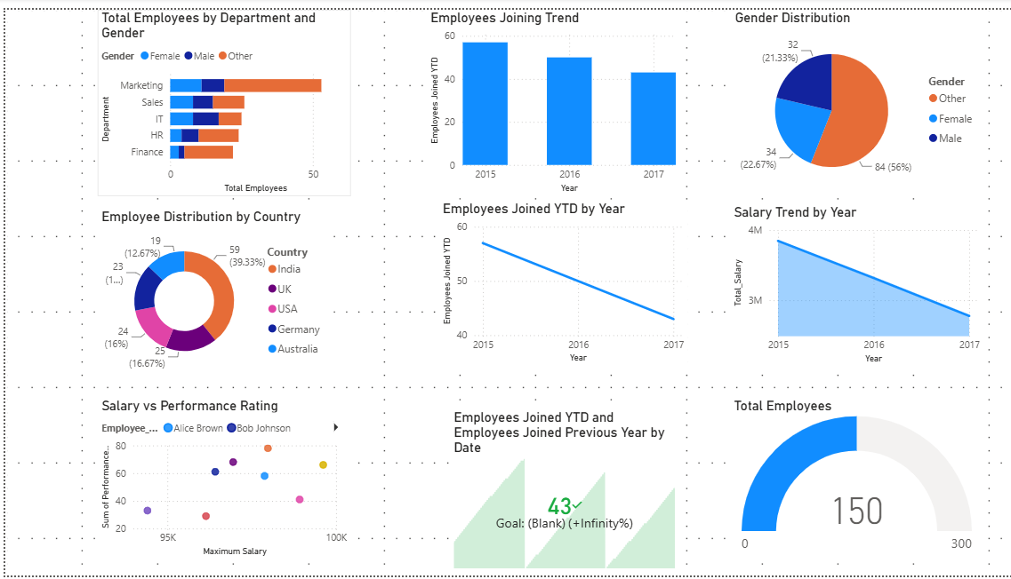
OBSERVATION:
1. A dashboard was created to present employee data in a clear and interactive format.
2. KPI cards display important metrics such as Total Employees, Total Salary, Average Salary, and Employees Joined YTD.
3. A stacked bar chart compares employee distribution across departments and genders.
4. A column chart shows the yearly employee joining trend.
5. Pie and donut charts visualize the distribution of employees by gender and country.
6. A line chart highlights employee joining trends over different years.
7.An area chart displays the salary trend across years.
8. A scatter chart analyzes the relationship between salary and employee performance.
9. A gauge visual provides a quick overview of employee count against a target.
10. The dashboard effectively summarizes key workforce metrics and trends, making the report easy to understand and supporting better decision-making.

